TITLE OF The PAPER (Times New Roman 14, bold, UPPERCASE, center, 42pts before)
Name SURNAME¹, Name SURNAME², Name SURNAME³
¹First author Affiliation,²Second author Affiliation,³Third author Affiliation
Corresponding author email
Abstract. Authors are asked to submit an abstract of at least 200 words and no more than 500 words. The title, author(s), affiliation(s), abstract, and keywords must fully match the data contained in the abstract submitted and accepted for CORTEP 2026. If there is no other corresponding author, that author will be considered the first author. If there are only two authors, please use the structure: AUTHOR 1 and AUTHOR 2. Affiliation includes only the following data for each author: Name of university/organization, City, and Country. This paragraph will be formatted as follows: Times New Roman, 10 pts., Justified, Spacing Before 24 pts, Spacing After 6 pts.
Keywords: Do not repeat the title, list 4-6 keywords, keyword 1, keyword2, keyword3, keyword4, keyword5.

1. INTRODUCTION (HEADING 1)
The paper must be written in English (United States) and prepared as an accessible Word document, following the PDF accessibility checklist at the end of this template, so that it can be accepted for production. It should be structured according to the following sections: INTRODUCTION (area of application, state-of-the-art, novelty, scope of the paper), EXPERIMENTAL, RESULTS AND DISCUSSIONS, CONCLUSIONS, Acknowledgements and REFERENCES.
The papers are restricted to min 4 and max 8 A4 pages.
Do not indent the beginning of the paragraphs. Do not add text to headers and footers.

2. EXPERIMENTAL PART (HEADING 1)
The writing style should be scientific (concise, clear and impersonal). Appendix 1 presents the List of paragraph styles.
With the exception of the equation, all other texts are written in Times New Roman font.
For Greek letters and mathematical symbols, type the Unicode character directly (e.g.: α β γ δ ε θ λ μ σ ω) or insert it (“Insert”, “Symbol”). Do not use the Symbol or Wingdings fonts: these use non-standard character encoding that fails accessibility checks and can display incorrectly in the exported PDF. For inline mathematical notation, the Microsoft Equation Editor (“Insert”, “Equation”) is preferred, as it encodes symbols correctly.

3. RESULTS AND DISCUSSION (HEADING 1)

3.1. Subsection-Figures, tables and equations (Heading 2)
Figures containing illustrations, diagrams, and/or other images should be included in the paper as jpg or gif, centered and in logical order, near where they are designated as Figure(s) in the text. Number them with Arabic numerals (consecutively throughout the paper). Every figure must have alternative text added in Word (right-click on the image, select “Edit Alt Text” and write the alternative text in the box; write 1-2 sentences describing the essential information shown by the figure; do not repeat the caption), or be marked as decorative (right-click on the image, select “Edit Alt Text” and then select “Mark as decorative”) if it carries no information beyond decoration.
Captions should be included below each Figure (Times New Roman, 10 pt., Normal, centered, Space before 6 pt. and Space after 6 pt.). Figures should be of high quality, and all notations used in the figures must be clearly legible. A caption does not replace Alt Text: the caption identifies the figure for sighted readers, while Alt Text describes its essential visual information for screen-reader users.
The layout of the figures should be consistent with the text. Do not use color alone to convey meaning in a figure (e.g. in charts or graphs); add text labels, symbols, or distinct line/fill patterns so the information is not lost for color-blind readers.
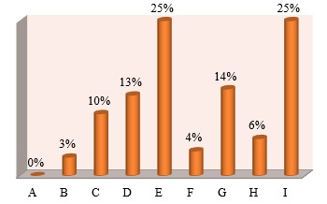
Figure 1. Title of figure (see the Figure style)

3.2. Subsection (Heading 2)
The rows and columns have the formatted text included in the tables as shown in Table 1. Tables must be created with Word’s “Insert”, “Table” (never submitted as images or screenshots), kept simple, and without merged or split cells.
The table must have a clear header row (created with Word’s “Table Design”, selecting “Header row”), marked to repeat (right-click on the table, “Table Properties”, select “Row” and then select “Repeat as header row”).
Every table must have alternative text added in Word (right-click on the table, select “Table proprieties” and then “Alt Text”. Insert the title and the alternative text in the box; write 1-2 sentences describing the essential information shown by the table; do not repeat the caption).
Table 1
Table name
Heading | Heading | Heading
………
Text | Text | Text
Equations should be centered and numbered consecutively throughout the paper. For mathematical equations, use Microsoft Equation Editor; do not insert equations as images or screenshots. Define all symbols immediately after the equation and introduce it briefly in the surrounding text.
Equations will be centered and numbered on the right, in round brackets.
$ρ=\frac{m}{V}$ (1)
where: ρ - density [g/cm³], m – mass, v - volume.

4. CONCLUSIONS
The conclusion should summarize the main contributions of the work, discuss the significance of the paper, suggest applications and future work related to the research, and point out some limitations of the present research.

Acknowledgements
Authors should acknowledge the support of colleagues, the special work of professionals, or the financial support of organizations (Times New Roman, 11). The title uses Times New Roman, 11 pt., Bold, Spacing Before 18 pts., Spacing After 6 pts.

REFERENCES
References should be listed at the end of the sentence using the Vancouver Reference style. References should be indicated in the text by a sequence number in square brackets [1] (with automatic connection to the source) and should be numbered in the order in which they appear in the text. Please check that it corresponds to the correct number in the reference list. All references should be complete so that they can be found by anyone wishing to follow them up.
To create an automatic link, use the Vancouver style recommendations.
If you have already written the text and bibliography manually, use “Cross-reference”. First number the bibliography. Go to the text where you want to put the number. Access the menu and select “Insert”, and then “Cross-reference”. Set the options: “Reference type” (“Numbered item”), “Insert as hyperlink”, “Insert reference to” (“Paragraph number”) and choose the source (select the correct source from the list and press “Insert”).
For books the place of publication is also required. For more than three authors, use the Surname, N. of the first author followed by et al. Please follow the examples:

- Surname, N.; Surname, N.: Book Title, Publisher, ISBN, Place of Publication (YYYY)
- Surname, N.: Book title, n^{th} ed., Publisher, year [E-book]
- Surname, N. & Surname, N.: Title of paper or Chapter, In Book Title, Surname, N. (ed.) Publisher, ISBN, Place of Publication, (YYYY), pp. xxx-yyy
- Surname, N..; Surname, N. & Surname, N.: Title of conference paper, in Proceedings of xxx, Surname, N. (Ed.), pp. xxx-yyy, conference location, period, publisher, city, (YYYY)
- Surname, N.: Paper Title, Journal, Vol. (YYYY) No., pp. xxx-yyy
- Surname, N. et al.: Paper Title, eJournal title, vol., no., pp., date year. Available from http://www.exact-address-of-site. Accessed: YYYY-MM-DD
- Surname, N.; Surname N. & Surname N.: Site Title, Available from http://www.exact-address-of-site. Accessed: YYYY-MM-DD

For further mandatory information, please see Technical Notes.

SENDING THE PAPER
Your paper (camera ready) must be submitted via Editorial Management System.

Please use the surname of the corresponding author to identify your paper, e.g., surname_cortep_full_paper.docx, surname_cortep_full_paper1.docx.

Technical Note

PDF ACCESSIBILITY AND ACCEPTANCE REQUIREMENTS
Paradigm Publishing Services – European Accessibility Act compliance: from June 2026, the European Accessibility Act (EAA) makes digital accessibility mandatory for all online academic publications distributed in the EU.
This checklist helps you meet these legal and editorial requirements. Delete this entire section before final submission.

A. Document structure and metadata
- Use the built-in styles of this template – Title, Heading 1, Heading 2, and the body-text/caption/reference styles – for their intended purpose. Do not create a heading using only bold text, uppercase, or a larger font size. See Appendix 1 (List of paragraph styles).
- Keep headings in logical order (Title: Heading 1 or Heading 2). Do not skip levels.
- Set the document language to English (United States): “Review”, “Language”, “Set Proofing Language” and “English (United Stated)”. If any text is quoted in another language, select it and set its own language the same way.
- The university and CORTEP 2026 logos in the document header are branding images; keep their Alt Text short and factual (already set in this template), or mark them as decorative if you replace them.
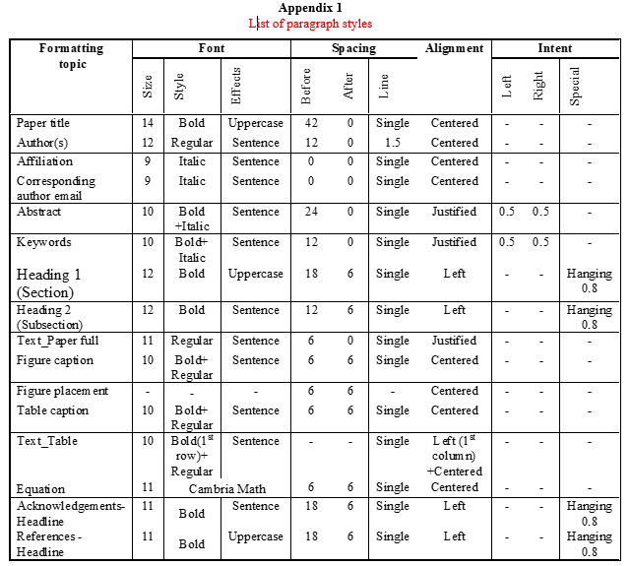

B. Figures, charts, images
- Every figure, chart, graph, scheme or photograph must have alternative text added in Word: right-click on the image, select “Edit Alt Text” and write the alternative text in the box.
- “Alt Text” must explain the information conveyed by the visual, not merely name it. Do not repeat the caption word-for-word and do not start with “an image of” or “a picture of”.
- Keep Alt Text short (100–150 characters with spaces is recommended). If the caption or surrounding text already fully describes the figure, use “See caption” or “See main text” instead of repeating it.
- For very complex visuals that cannot be summarized, add a longer description as plain text immediately after the caption (e.g.: “Long description: …”), in addition to the short Alt Text.
- Purely decorative graphics may be marked as decorative instead of given Alt Text (right-click on the image, select “Edit Alt Text” and then select “Mark as decorative”).
- Never rely on a figure alone to convey key data: state the important values or conclusions in the surrounding text as well, do not add interpretation in “Alt Text” that a sighted reader would not see on the figure itself, and check that Alt Text is spelled and punctuated correctly.
- Do not use color alone to convey meaning; add text labels, symbols, or different line/fill patterns. Place figures as inline objects (not floating text boxes) to preserve a logical reading order.

C. Tables
- Create tables with “Insert” and “Table”. Never submit a table as an image, drawing, screenshot, or tab-separated text.
- Use a simple structure: one clear header row, no merged or split cells, no nested tables, no blank rows or columns.
- Mark the first row as a header row: “Table Design”, and “Header row”.
- Mark the first row to repeat: right-click on the table, “Table Properties”, select “Row” and then select “Repeat as header row”.
- Tables are read as structured text by screen readers. For each table add a short description of its structure: right-click on the table, select “Table proprieties” and then “Alt Text”. Insert the title and the alternative text in the box; write 1-2 sentences describing the essential information shown by the table; do not repeat the caption.
- Where possible, present data as a simple list instead of a table: tables are only accessible to a certain degree and require more effort from screen-reader users to navigate.

D. Symbols, equations, hyperlinks
- Use Unicode characters for Greek letters and symbols. Do not use the Symbol or Wingdings fonts for running text – they use non-standard encoding that breaks accessibility and PDF tagging.
- Create equations with “Insert”, “Equation” (Microsoft Equation Editor or MathType). Never use a screenshot of an equation. Define all symbols immediately after the equation.
- For hyperlinks, select descriptive text and press Ctrl+K to add the link. Avoid vague link text such as “click here” or a bare URL. Exception: links within the reference list do not need separate descriptive text, since the reference itself describes what the link points to.
- Every in-text citation number (e.g.: [1]) should be linked to its entry in the reference list, so a screen-reader user can jump directly to the source.
- To create an automatic link, use the Vancouver style recommendations.
- If you have already written the text and bibliography manually, use “Cross-reference”. First number the bibliography. Go to the text where you want to put the number. Access the menu and select “Insert”, and then “Cross-reference”. Set the options: “Reference type” (“Numbered item”), “Insert as hyperlink”, “Insert reference to” (“Paragraph number”) and choose the source (select the correct source from the list and press “Insert”).

E. Color and lists
- Do not use color, highlighting, or font color.
- Use Word’s built-in bullet and numbering tools (“Home” and “Bullets” or “Numbering”). Do not create a list manually with hyphens, asterisks, or typed numbers followed by a period.
- Keep the template’s Times New Roman font: it is a legible font with distinct character shapes (uppercase I, lowercase l, and number 1 do not look identical). Do not switch body text to a purely decorative or script font.

F. Final clean-up for finale check (mandatory)
- Delete all template instructions, author guidance, examples.
- Do not delete the actual “Alt Text” entered through right-click. It is invisible on the page but must remain embedded in the Word file.
- Do not delete accessible structure: heading styles, table header-row settings, descriptive hyperlinks, document language, document title/metadata, figure captions, table captions, or equation numbering.
- Final check: from the Word menu select “Review” and then “Check Accessibility”. Correct any remaining warnings.

THE SUBMISSIONS THAT DO NOT COMPLY WITH THE ABOVE GUIDELINES WILL BE REJECTED FOR FORMAL REASONS!

